Continuing Education Credit Hours Report
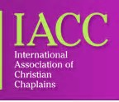
Please list all continuing education (CE) hours. You must have completed 50 hours by your anniversary date. The CE should be specific to chaplaincy and/or professional development. Attach the Continuing Education Credit Hours Report t to your Annual Membership Update Report. You may use additional pages if necessary.
  - Classes/Seminars/Research/Teaching
Date | Title | Credit Hours

  - Books Read : One hour of reading is equivalent to one hour CE credit.
Date | Book Read | Hours Read

  - IACC/Local Chapter Meeting Attended: One hour of meetings is equivalent to one hour CE credit.
Date | IACC/Chapter Meeting | Hours Attended

Total number of CE credits:

